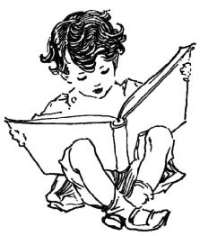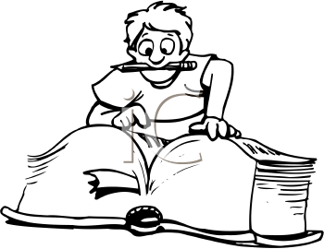

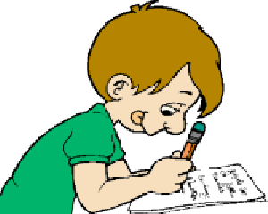

άλογο

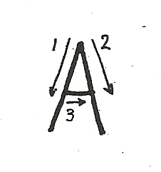

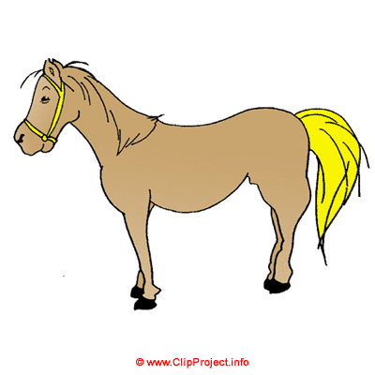

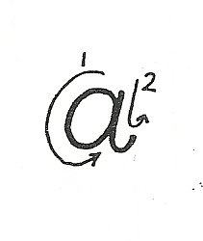

Α α, Α α, Α α, Α α, Α α, Α α, Α α

Α α, ........................................................................................

Α α, ........................................................................................

Α α, ........................................................................................

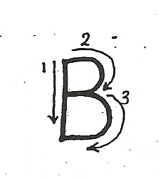

βαρέλι

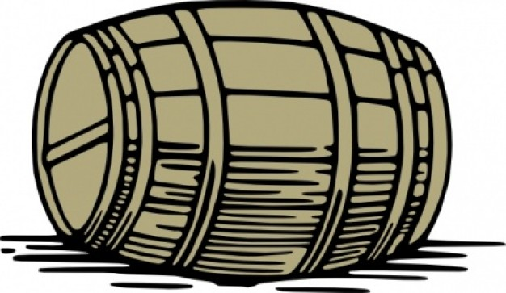

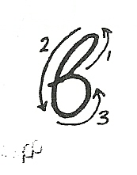

Β β, Β β, Β β, Β β, Β β, Β β, Β β

Β β, ........................................................................................

Β β, ........................................................................................

Β β, ........................................................................................

γάτα

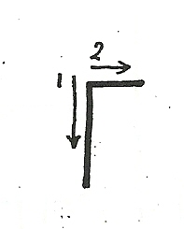

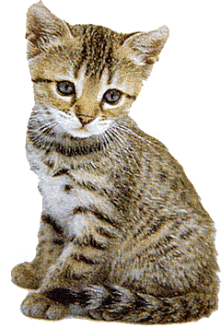

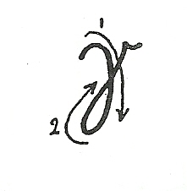

Γ γ, Γ γ, Γ γ, Γ γ, Γ γ, Γ γ, Γ γ

Γ γ, ........................................................................................

Γ γ, ........................................................................................

Γ γ, ........................................................................................

δώρο

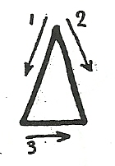



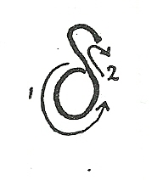

Δ δ, Δ δ, Δ δ, Δ δ, Δ δ, Δ δ, Δ δ

Δ δ, ........................................................................................

Δ δ, ........................................................................................

Δ δ, ........................................................................................

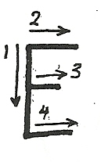

ελέφαντας

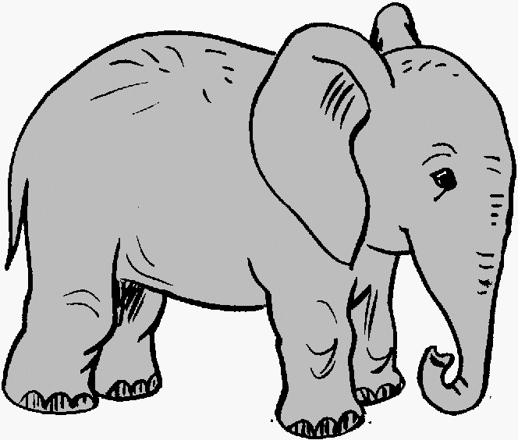

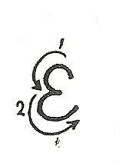

Ε ε, Ε ε, Ε ε, Ε ε, Ε ε, Ε ε, Ε ε

Ε ε, ........................................................................................

Ε ε, ........................................................................................

Ε ε, ........................................................................................

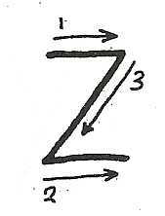

ζάρι

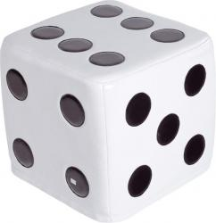

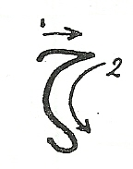

Ζ ζ, Ζ ζ, Ζ ζ, Ζ ζ, Ζ ζ, Ζ ζ, Ζ ζ

Ζ ζ, ........................................................................................

Ζ ζ, ........................................................................................

Ζ ζ, ........................................................................................

ήλιος

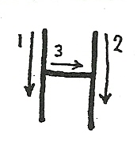



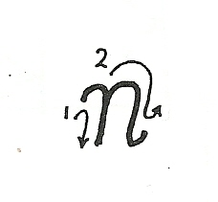

Η η, Η η, Η η, Η η, Η η, Η η, Η η

Η η, ........................................................................................

Η η, ........................................................................................

Η η, ........................................................................................

θάλασσα

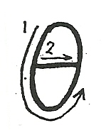

[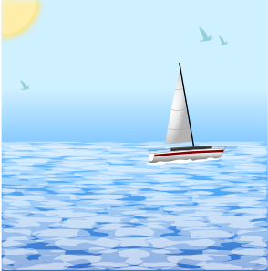](javascript:edit(14474))

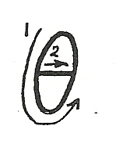

Θ θ, Θ θ, Θ θ, Θ θ, Θ θ, Θ θ, Θ θ

Θ θ, ........................................................................................

Θ θ, ........................................................................................

Θ θ, ........................................................................................

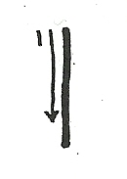

ινδιάνος



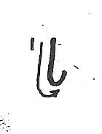

Ι ι, Ι ι, Ι ι, Ι ι, Ι ι, Ι ι, Ι ι

Ι ι, ........................................................................................

Ι ι, ........................................................................................

Ι ι, ........................................................................................

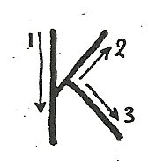

κότα

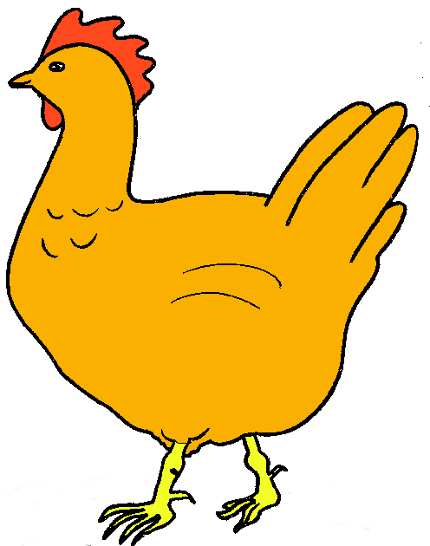

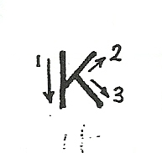

Κ κ, Κ κ, Κ κ, Κ κ, Κ κ, Κ κ, Κ κ

Κ κ, ........................................................................................

Κ κ, ........................................................................................

Κ κ, ........................................................................................

λεμόνι

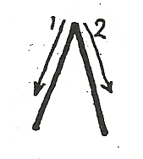

[](javascript:edit(3991))

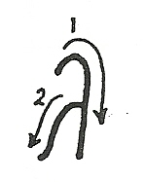

Λ λ, Λ λ, Λ λ, Λ λ, Λ λ, Λ λ, Λ λ

Λ λ, ........................................................................................

Λ λ, ........................................................................................

Λ λ, ........................................................................................

μολύβι

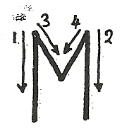



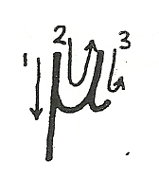

Μ μ, Μ μ, Μ μ, Μ μ, Μ μ, Μ μ, Μ μ

Μ μ, .......................................................................................

Μ μ, .......................................................................................

Μ μ, .......................................................................................

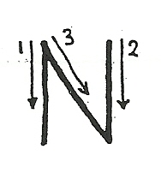

νερό

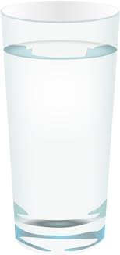

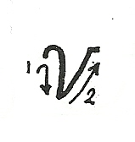

Ν ν, Ν ν, Ν ν, Ν ν, Ν ν, Ν ν, Ν ν

Ν ν, ........................................................................................

Ν ν, ........................................................................................

Ν ν, ........................................................................................

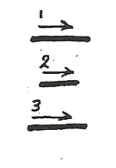

ξύλα

[](javascript:edit(25040))

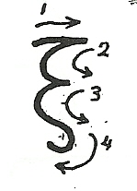

Ξ ξ, Ξ ξ, Ξ ξ, Ξ ξ, Ξ ξ, Ξ ξ, Ξ ξ

Ξ ξ, ........................................................................................

Ξ ξ, ........................................................................................

Ξ ξ, ........................................................................................

ομπρέλα

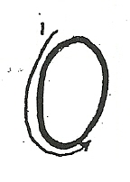

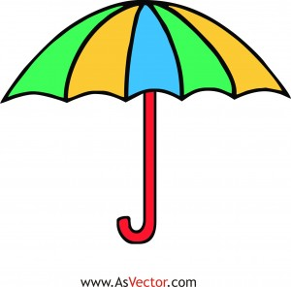

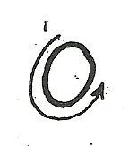

Ο ο, Ο ο, Ο ο, Ο ο, Ο ο, Ο ο, Ο ο

Ο ο, ........................................................................................

Ο ο, ........................................................................................

Ο ο, ........................................................................................

παγωτό

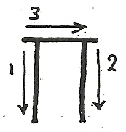

[](javascript:edit(4129))

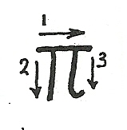

Π π, Π π, Π π, Π π, Π π, Π π, Π π

Π π, ........................................................................................

Π π, ........................................................................................

Π π, ........................................................................................

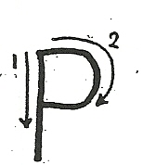

ράδιο

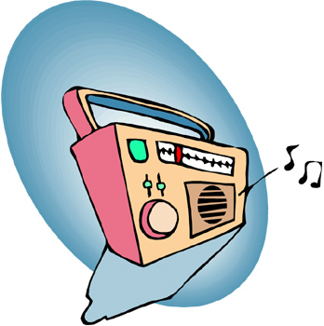

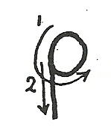

Ρ ρ, Ρ ρ, Ρ ρ, Ρ ρ, Ρ ρ, Ρ ρ, Ρρ

Ρ ρ, ........................................................................................

Ρ ρ, ........................................................................................

Ρ ρ, ........................................................................................

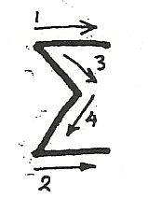

σκύλος

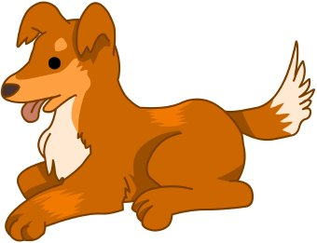

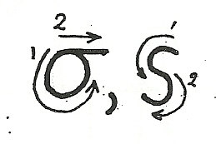

Σ σ ς, Σ σ ς, Σ σ ς, Σ σ ς, Σ σ ς, Σ σ ς

Σ σ ς, ......................................................................................

Σ σ ς, ......................................................................................

Σ σ ς, ......................................................................................

τηλέφωνο

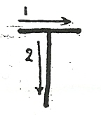

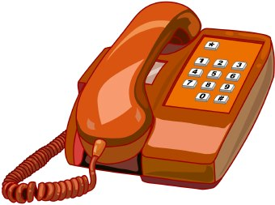

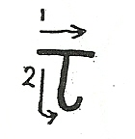

Τ τ, Τ τ, Τ τ, Τ τ, Τ τ, Τ τ, Τ τ

Τ τ, ........................................................................................

Τ τ, ........................................................................................

Τ τ, ........................................................................................

ύφασμα

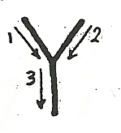

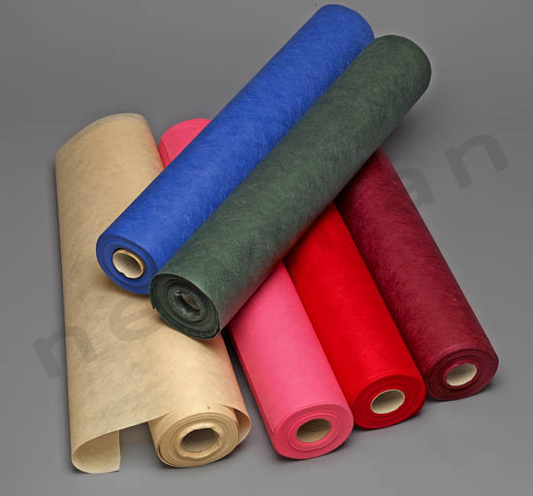

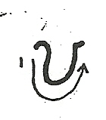

Υ υ, Υ υ, Υ υ, Υ υ, Υ υ, Υ υ, Υ υ

Υ υ, .......................................................................................

Υ υ, .......................................................................................

Υ υ, .......................................................................................

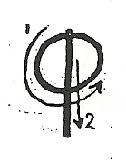

φίδι

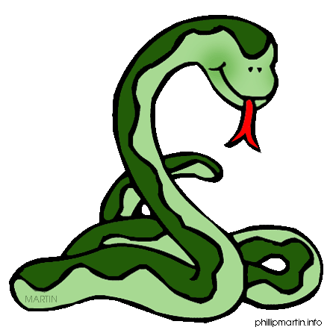

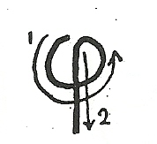

Φ φ, Φ φ, Φ φ, Φ φ, Φ φ, Φ φ, Φ φ

Φ φ, ........................................................................................

Φ φ, ........................................................................................

Φ φ, ........................................................................................

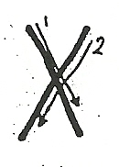

χελώνα

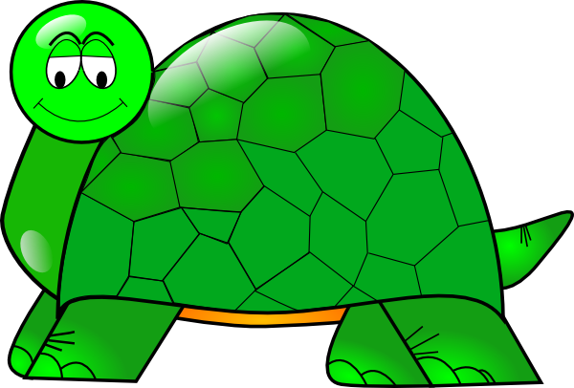

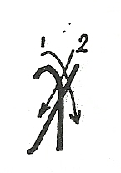

Χχ, Χ χ, Χ χ, Χ χ, Χ χ, Χ χ, Χ χ

Χ χ, ........................................................................................

Χ χ, ........................................................................................

Χ χ, ........................................................................................

ψάρι

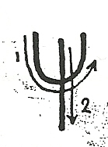



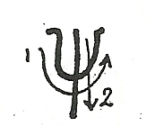

Ψ ψ, Ψ ψ, Ψ ψ, Ψ ψ, Ψ ψ, Ψ ψ, Ψ ψ

Ψ ψ, ........................................................................................

Ψ ψ, ........................................................................................

Ψ ψ, ........................................................................................

ώρα

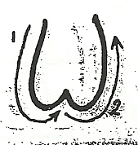

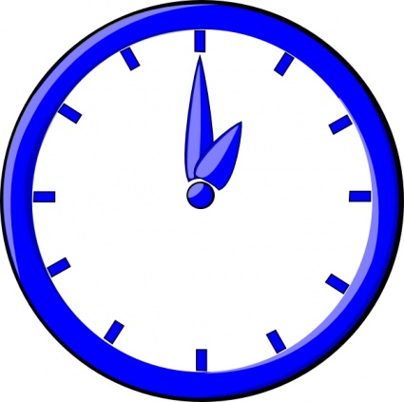

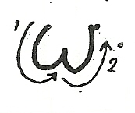

Ω ω, Ω ω, Ω ω, Ω ω, Ω ω, Ω ω, Ω ω

Ω ω, ........................................................................................

Ω ω, ........................................................................................

Ω ω, ........................................................................................